LGB with original tsfresh features

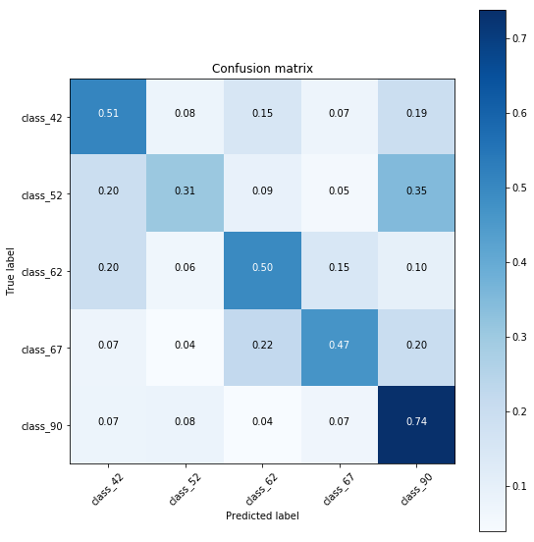

XGB with original tsfresh features

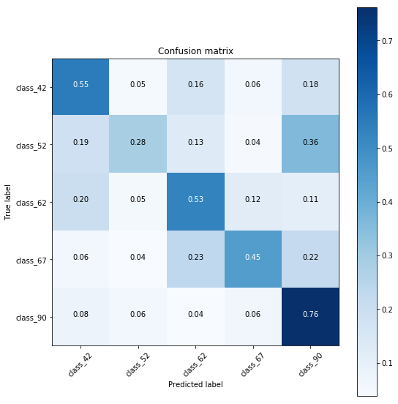

LGB with new tsfresh features

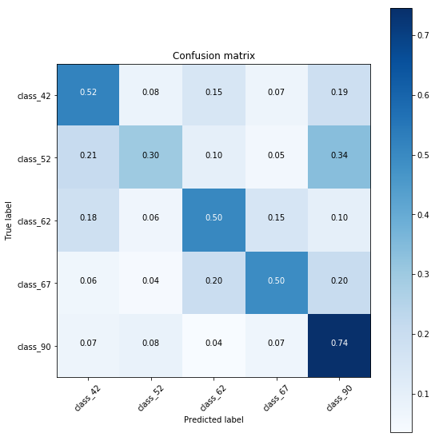

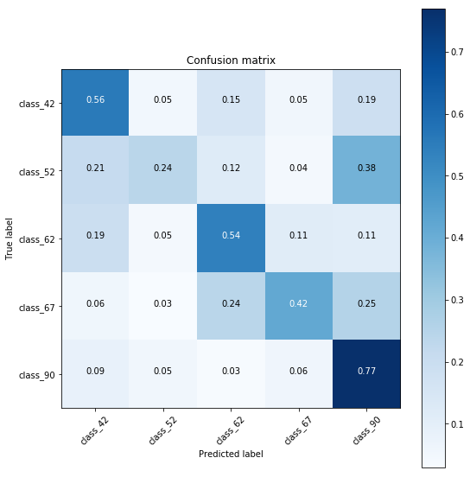XGB with new TSfresh features

LGB WITH SQUARED DISTANCE HAVERSINE

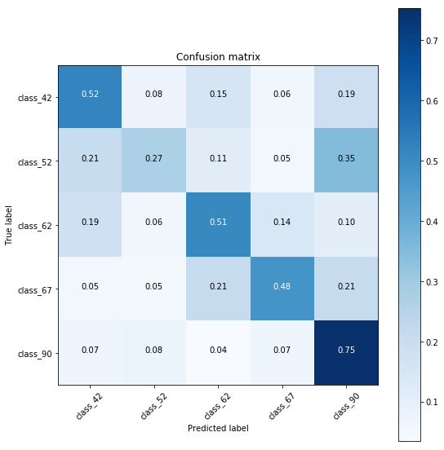

LGB WITH FLUX PASSBAND TSFRESH



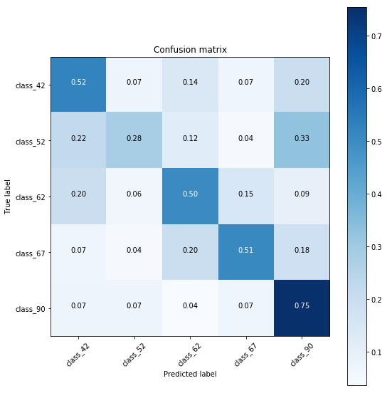

LGB WITHOUT FLUX PASSBAND TSFRESH

LGB WITH NEW TSFRESH + DWT (5-LVL)



LGB WITH NEW TSFRESH + DWT (6-LVL)

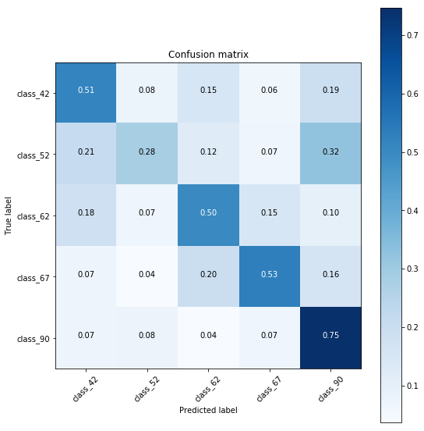

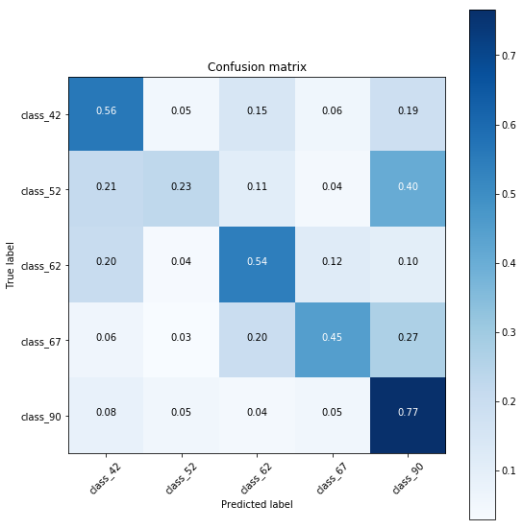XGB WITH NEW TSFRESH + DWT (5-LVL)

FINAL SUBMISSION CONFUSION PLOT – LGB

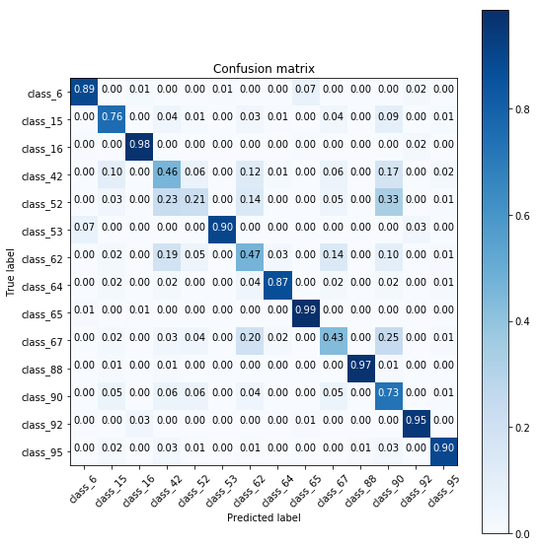

FINAL SUBMISSION – XGB

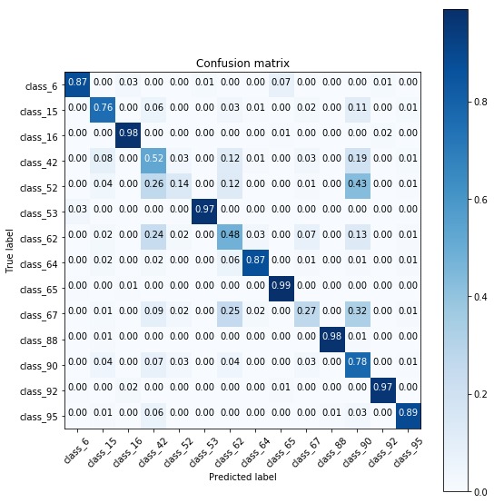

FINAL SUBMISSION – SECOND LEVEL LGB

